**Database**

Structured Collection of data that is organized and stored for efficient retrieval and manipulation.

Can store various type of data, such as text, numbers, images and more.

Provide a way to store and manage large volumes of data in a consistent and structured manner.

**Database Management System (DBMS)**

 Software system that facilitates the creation, manipulation, and management of database.

Act as an interface between users or application and the physical database.

**Types of DBMS**

1. Relational DBMS: Data stored in tabular forms linked with some relationships  
                               Example: - MYSQL, SQL Server, Oracle
2. Non-relational DBMS: Doesn't have any table or relationship.  
                                 Example: - NoSQL

**MYSQL**

Open-source RDBMS

Widely used for storing, manipulating and retrieving data

**SQL DATATYPES**

Provides a variety of datatypes that allows you to specify the type of data that can be stored in each column of a database table.

Eg:- Numeric Type

* int or integer (-2,0,55)
* SMALLINT
* BIGINT
* FLOAT
* DOUBLE or REAL
* DECIMAL or NUMERIC

Character String Types

* CHAR
* VARCHAR

Binary String Types

* BINARY
* VARBINARY
* BLOB

Boolean Types

* Returns True or False

Date and Time

* DATE: Date values ( Example:- '2002'-05-11')
* TIME:  Time values (Example: - '16:20:00')
* DATETIME or TIMESTAMP: Date and time Values (Example: - ‘2002'-05-11 16:20:00)

**SQL COMMANDS**

1. Create and Use Databases

* CREATE DATABASE database_name: creates a new database with the specified name.
* USE database_name: selects the database you just created, so you can start working with it.

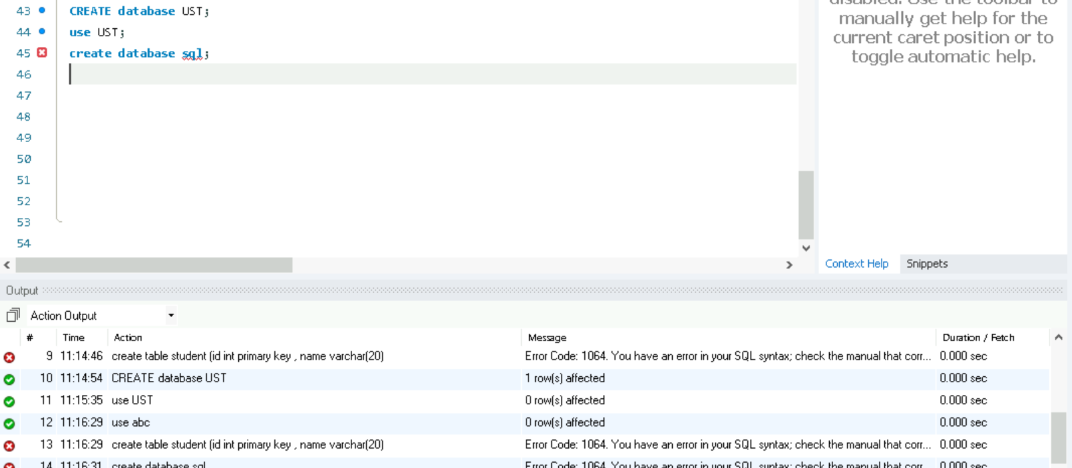

**Error Code: 1064**

Error 1064 in SQL is a syntax error, which means MySQL (or whatever SQL     engine you're using) didn't understand your query because something is written incorrectly.

Here word sql is identifier and cannot be used.

**Troubleshoo**t-Create database with non-identifier.

1. Truncate

Truncate deletes table data without deleting the schema.

Here the truncate is performed with the following data in the Table Records.

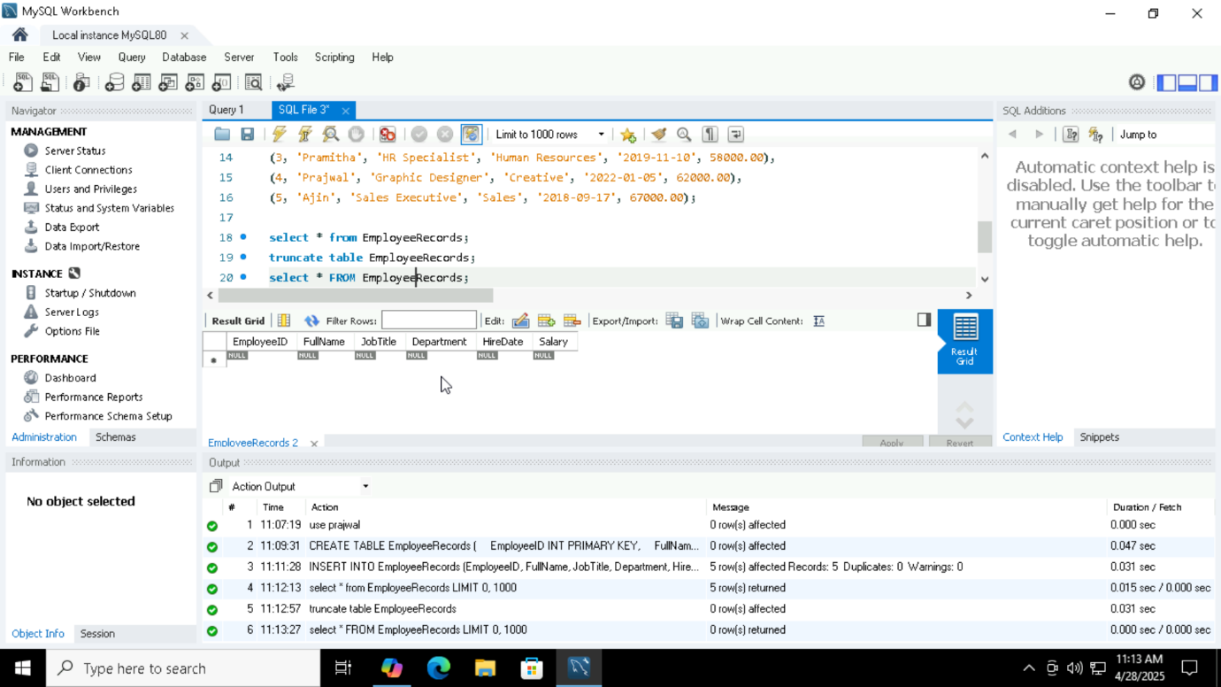

1. Null

Null means no value or unknown values , it is not same as 0 or empty string .

Null means the field has nothing in it.

Here we inserted the null values in table and the table is executed with the null value in the table.

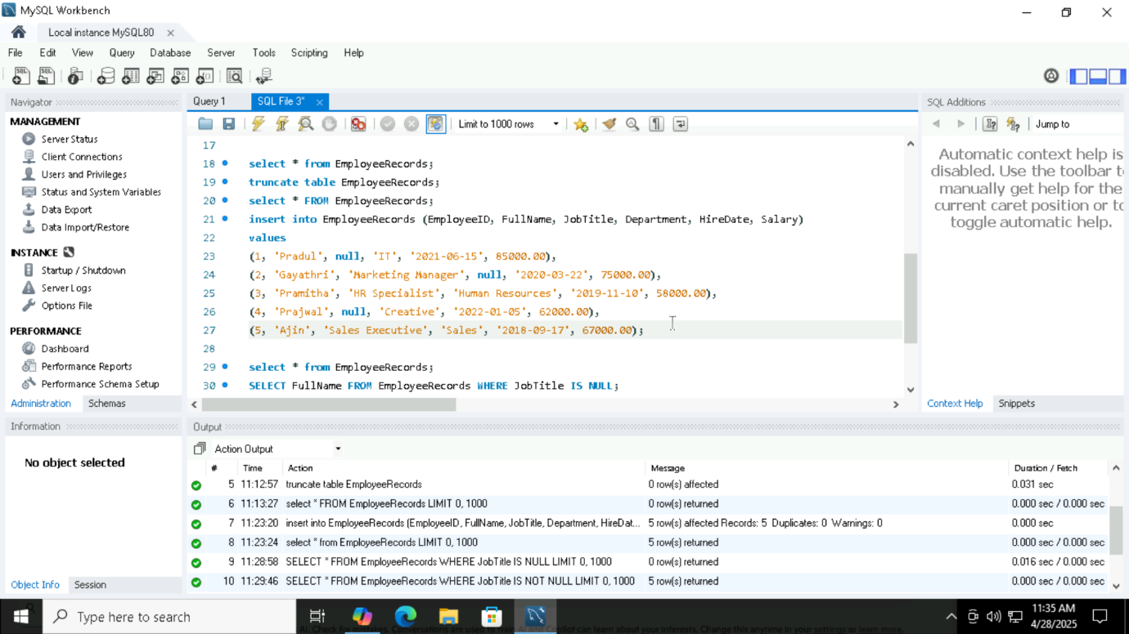

1. Auto Increment

auto increment: The AUTO_INCREMENT attribute in SQL is used to automatically generate a unique value for a column in a table.

It's commonly applied to primary key columns so that each new row gets a unique identifier without manually specifying it.

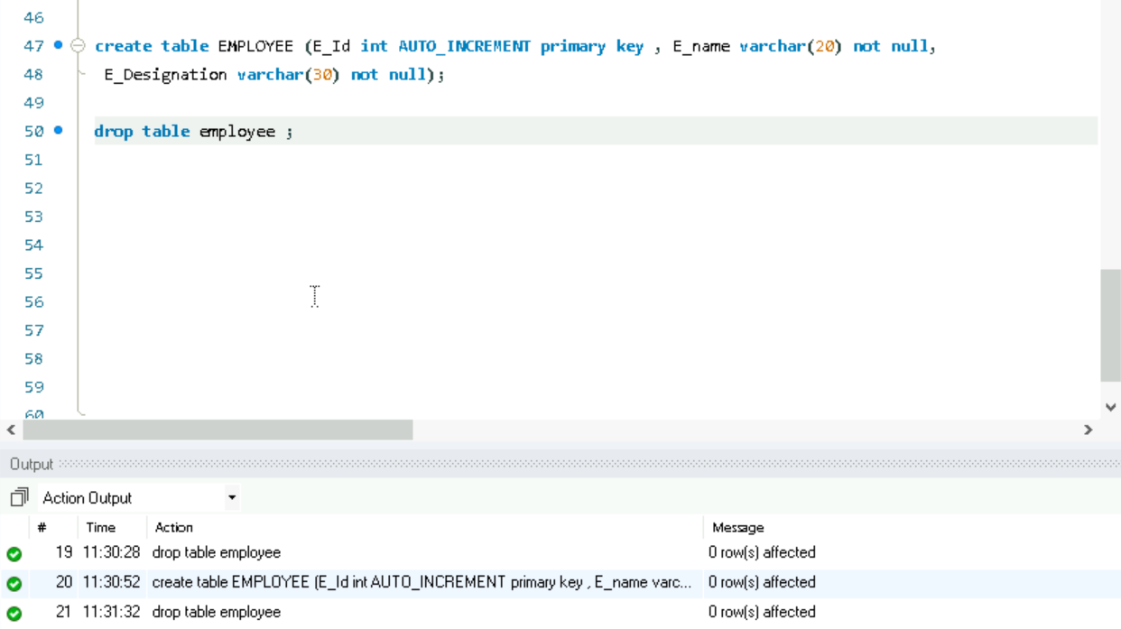

1. Min and Max

Min() is used to get smallest value.

Max() is to get the largest record or the highest value.

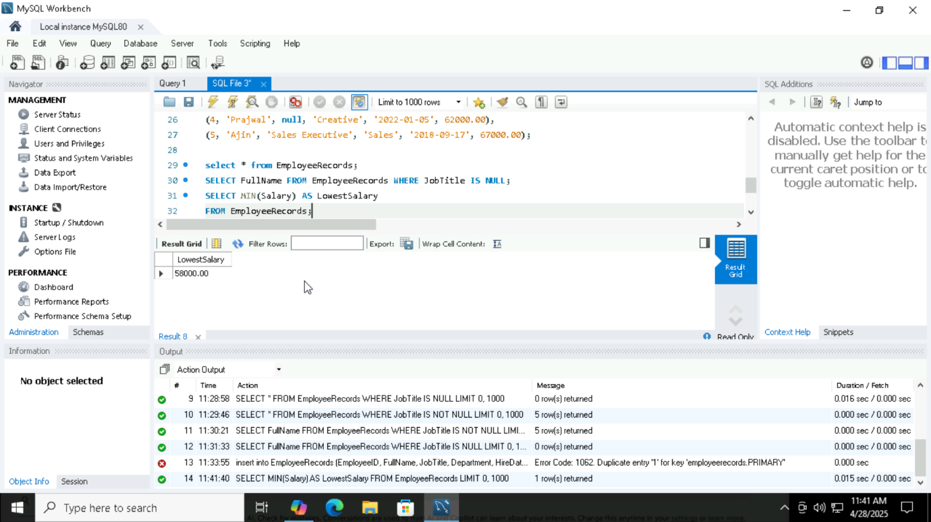

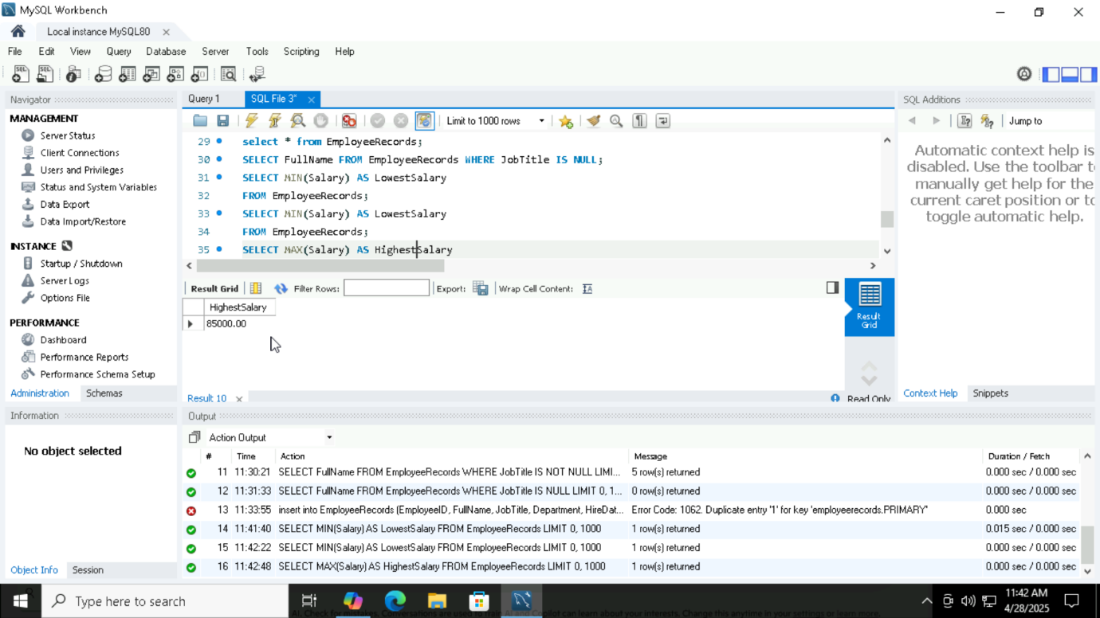

1. Where, Or, And

WHERE: Used to specify a condition in a query.

OR: Used to specify multiple conditions where at least one must be true.

AND: Used to specify multiple conditions where all must be true.

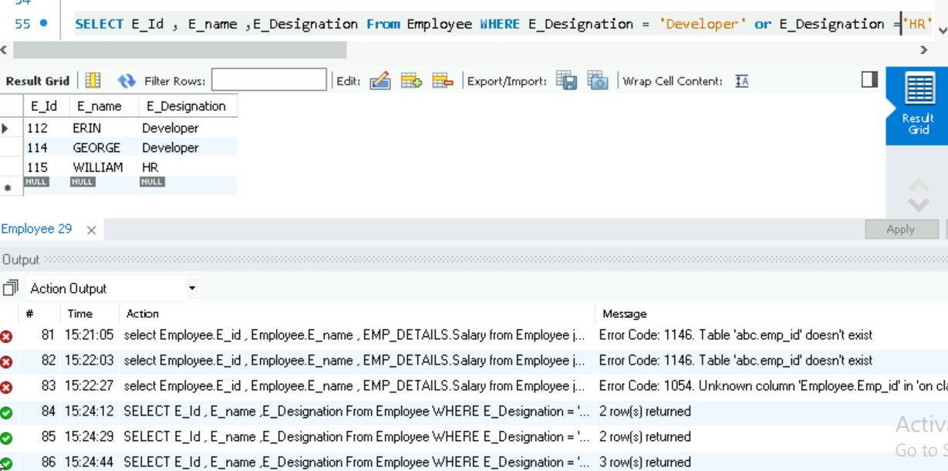

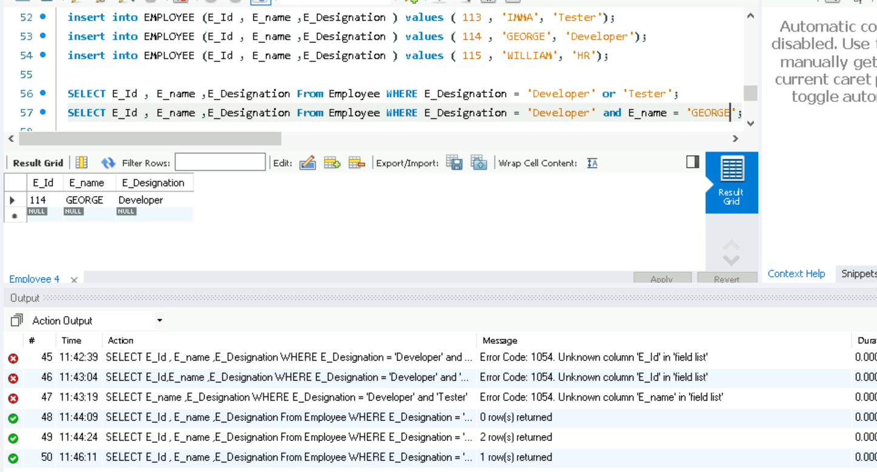

1. Count, Avg, Sum

Count() is used to get the count of the rows in a table.

Avg() is used to get the avg of the rows in a table.

Sum() is used to get the sum of the rows in a table.

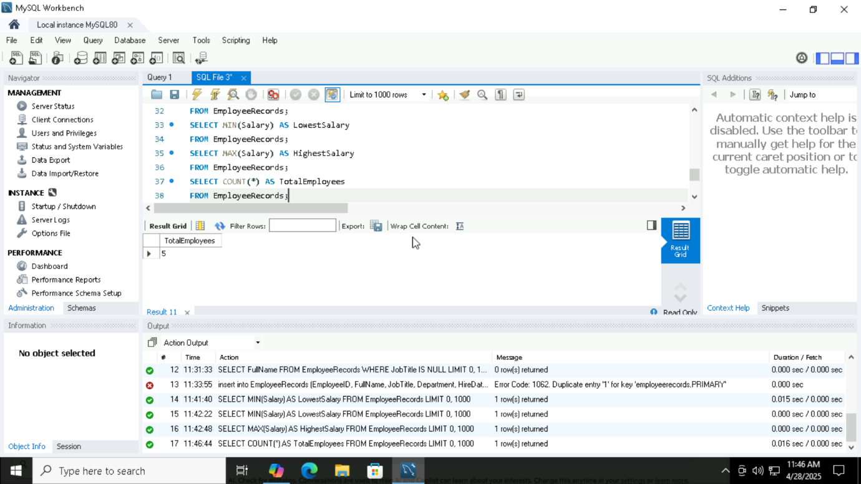

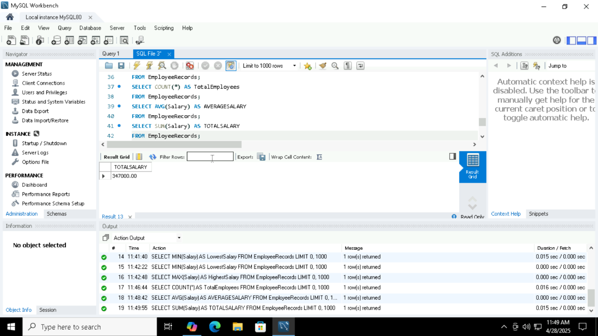

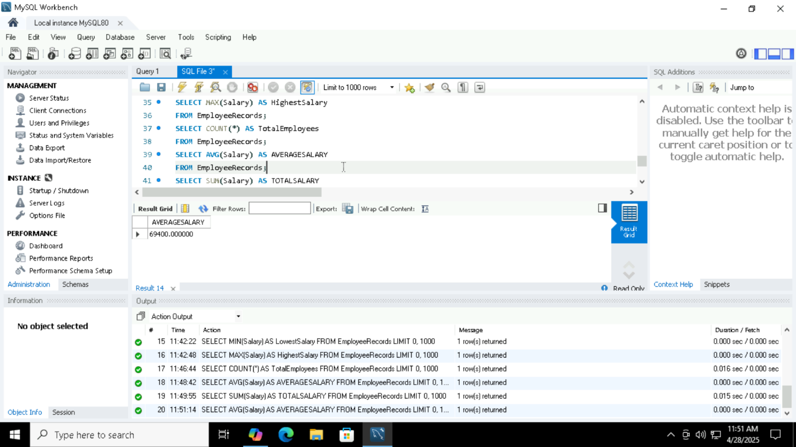

1. Like

**Starts with a pattern**: LIKE 'A%' finds all values starting with "A".

**Ends with a pattern**: LIKE '%Z' finds all values ending with "Z".

**Contains a pattern**: LIKE '%XYZ%' finds all values containing "XY"

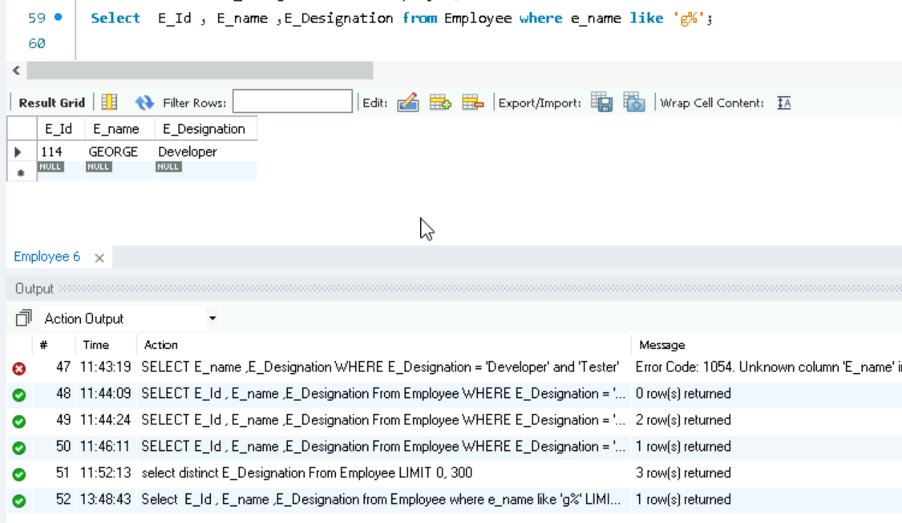

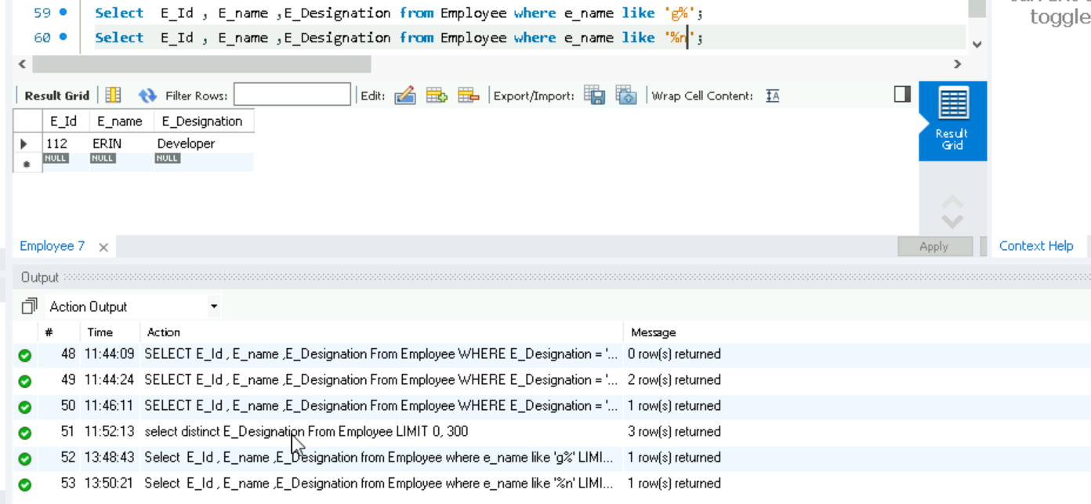

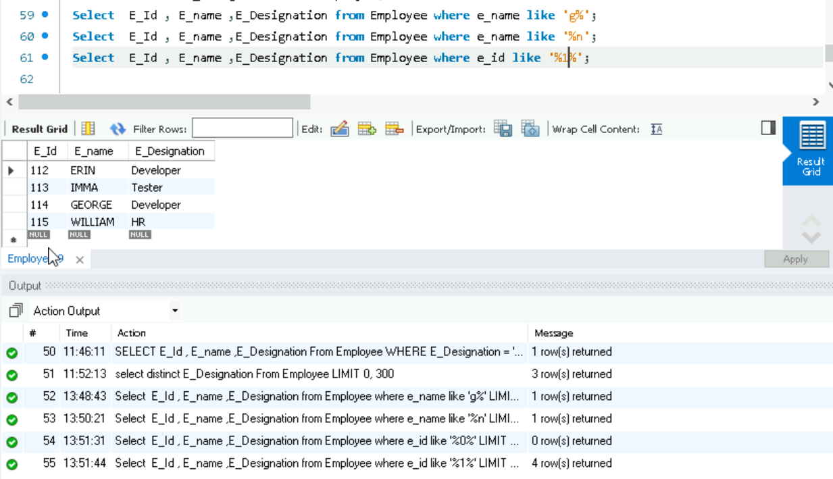

1. Underscore(_)

_x → Matches any **single** character followed by "a".

x_ → Matches "a" followed by **any single** character.

x__ → Matches "a" followed by **two** characters.

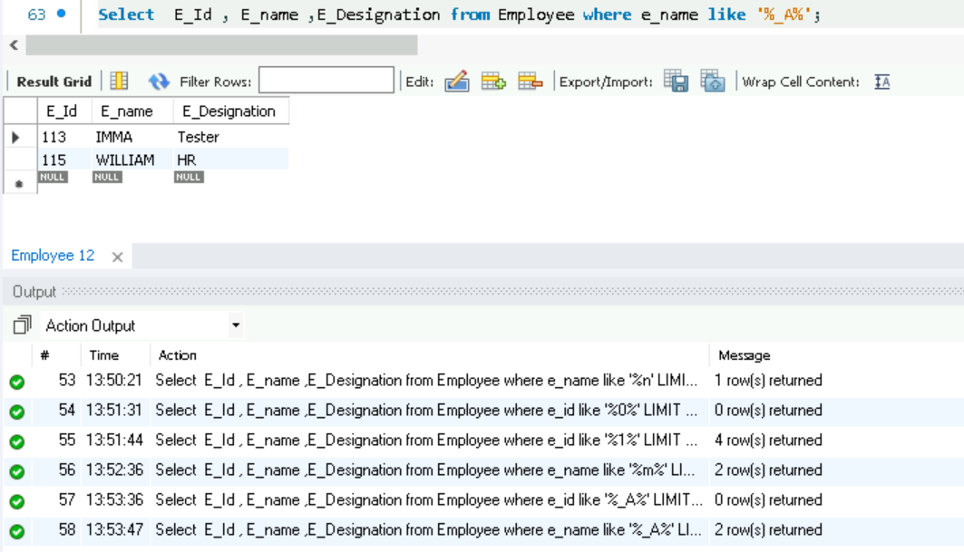

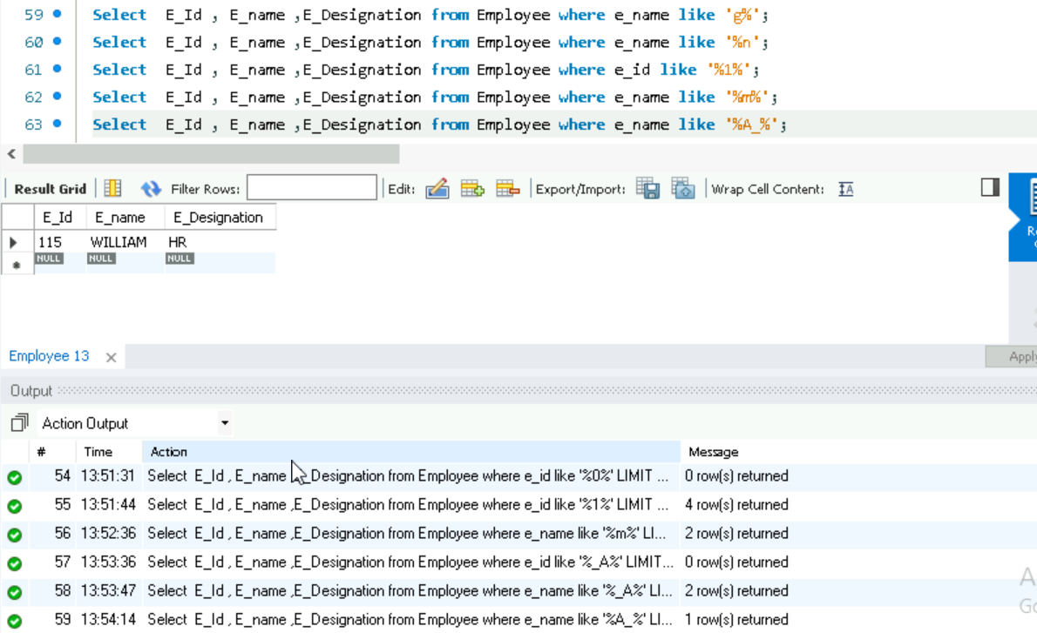

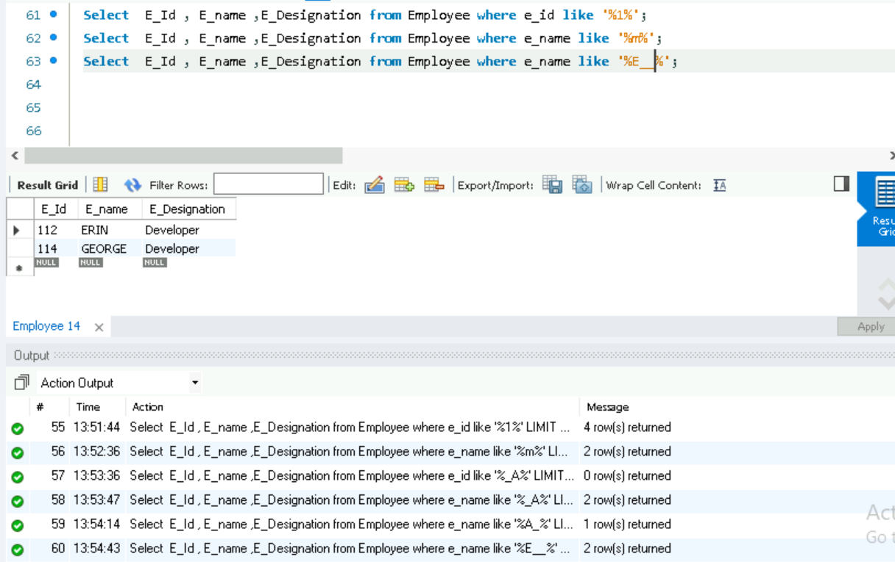

1. Distinct

The DISTINCT keyword in SQL is used to retrieve unique values from a column, eliminating duplicates from the result set.

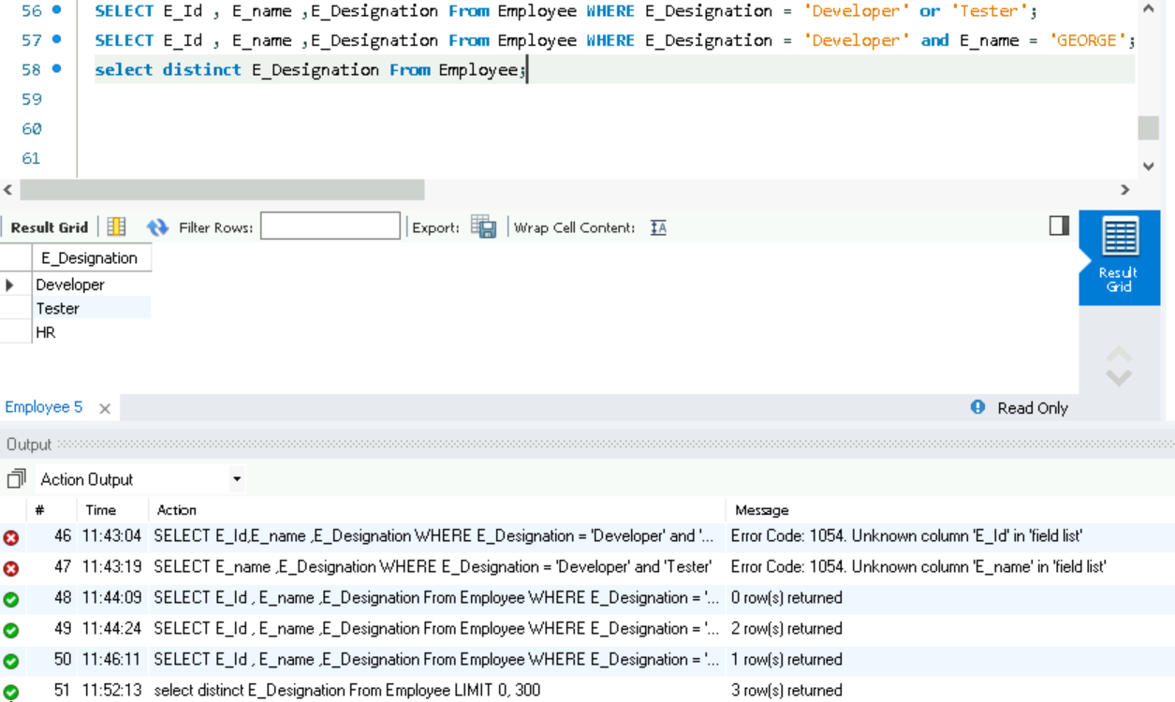

1. Limit , order by , order by desc

1.LIMIT – Restricts the number of rows returned.

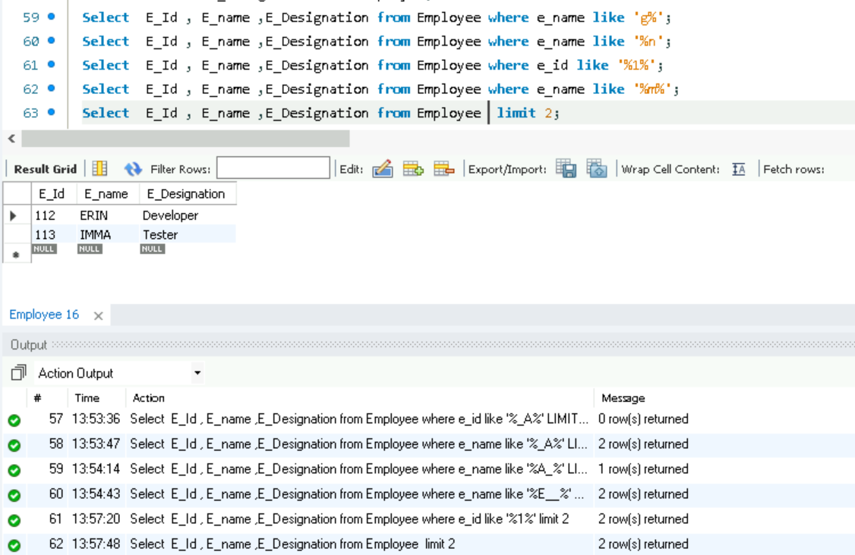

2.ORDER BY – Sorts the result set based on one or more columns.

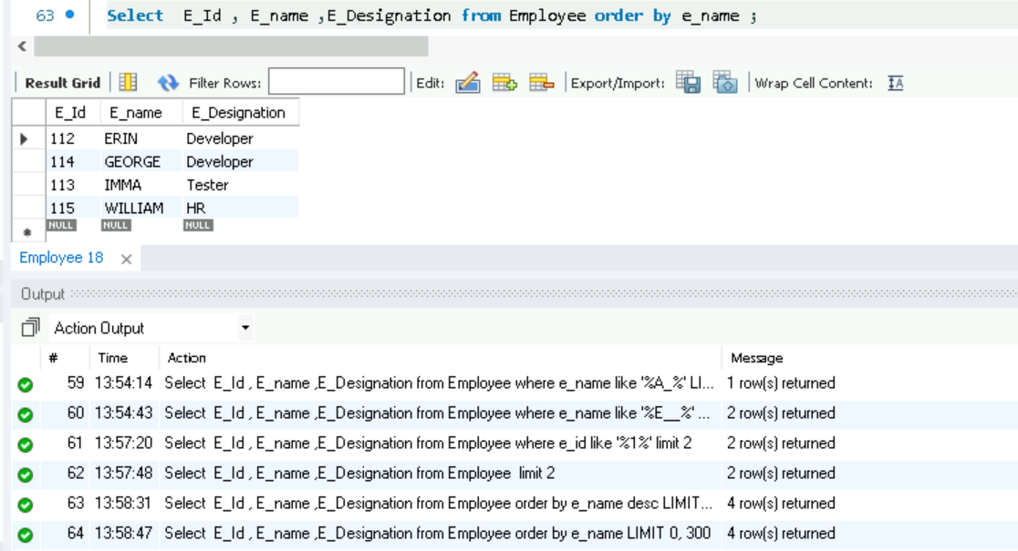

3.ORDER BY DESC – Sorts the result set in **descending** order.



1. desc table, in , between, alias

In SQL, the DESC (short for **DESCRIBE**) command is used to display the structure of a table, including column names, data types, and constraints.

IN – Used to filter results based on a list of values.

BETWEEN – Selects values within a range (inclusive).

ALIAS – Assigns temporary names to columns or tables.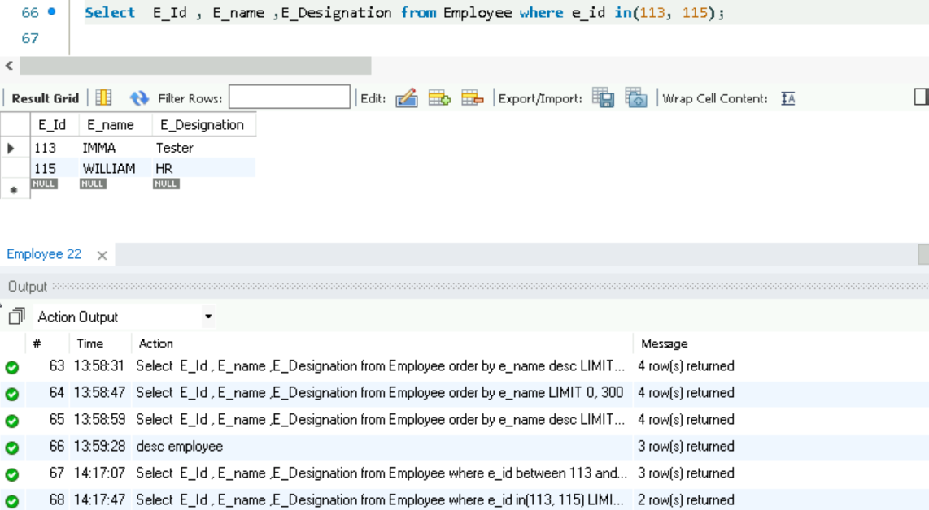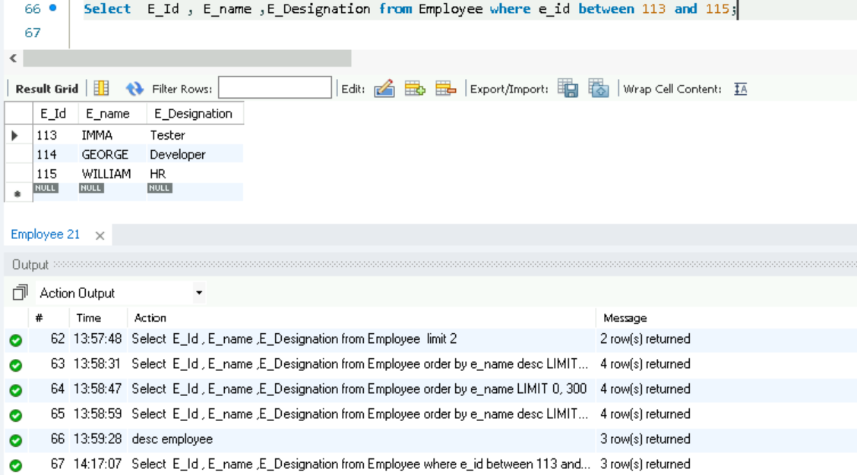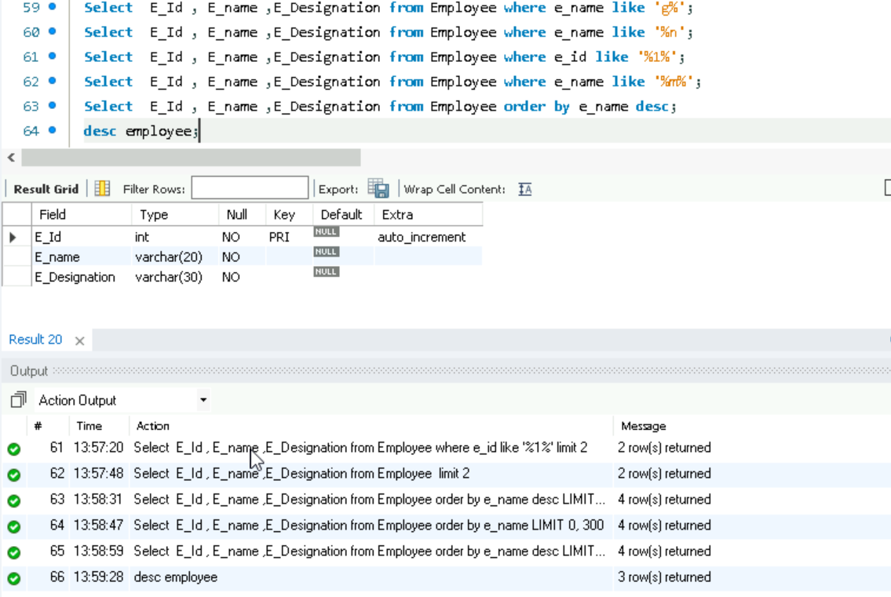

**JOIN**

* 1. **INNER JOIN**: Returns only the rows where there is a match in both tables.

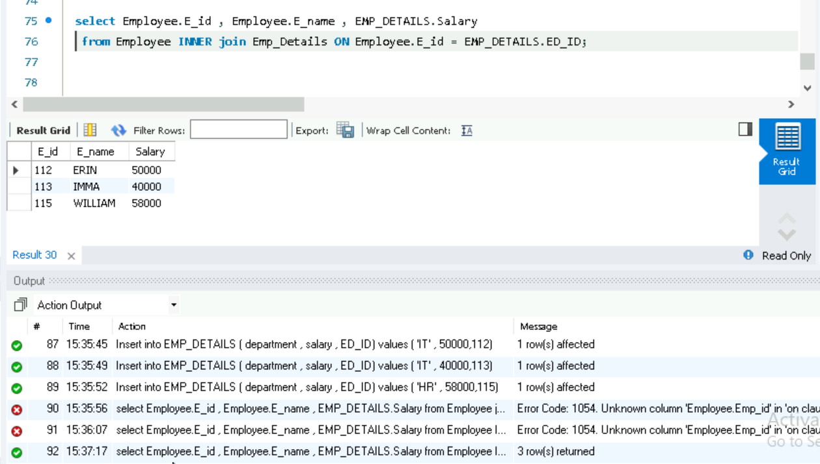

2. **LEFT JOIN (LEFT OUTER JOIN)**: Returns all rows from the left table, and the matched rows from the right table. If there’s no match, NULL values are returned for columns from the right table.

3. **RIGHT JOIN (RIGHT OUTER JOIN)**: Returns all rows from the right table, and the matched rows from the left table. If there’s no match, NULL values are returned for columns from the left table.

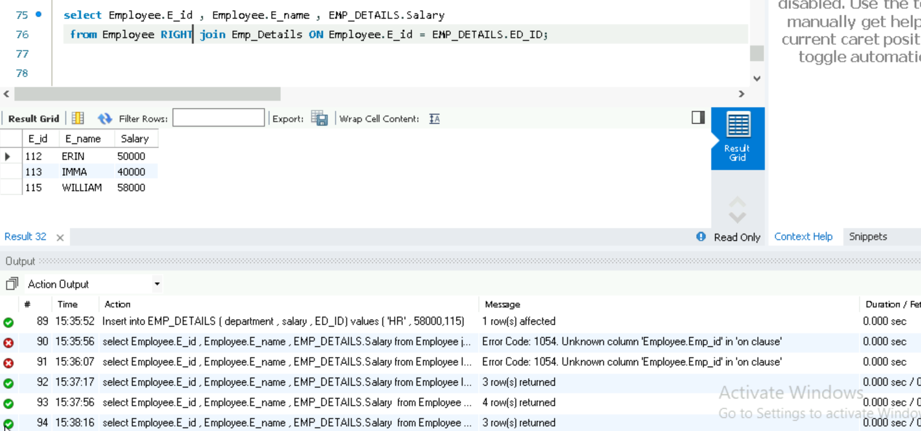

4. **FULL JOIN (FULL OUTER JOIN)**: Returns all rows when there is a match in one of the tables. If there’s no match, NULL values are returned for columns from the table without a match.

UNION

The UNION operator in SQL is used to combine the results of two or more SELECT statements into a single result set. It removes duplicate rows by default.

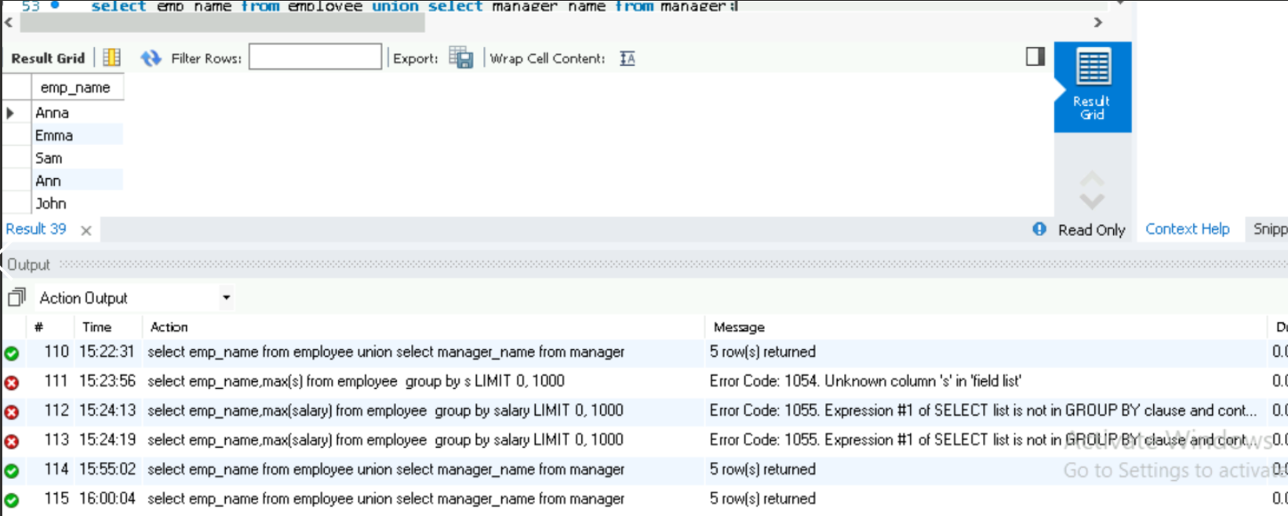

GROUP BY – Groups rows that have the same values in specified columns.

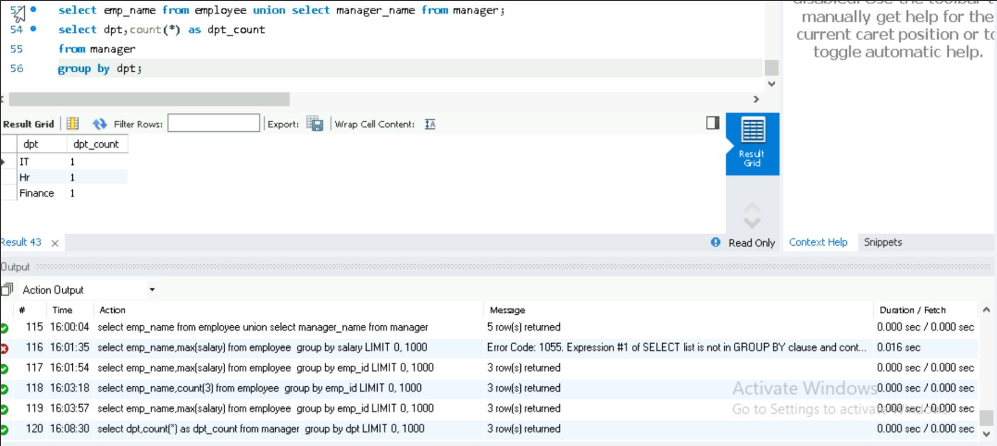

HAVING – Filters grouped results based on aggregate functions.

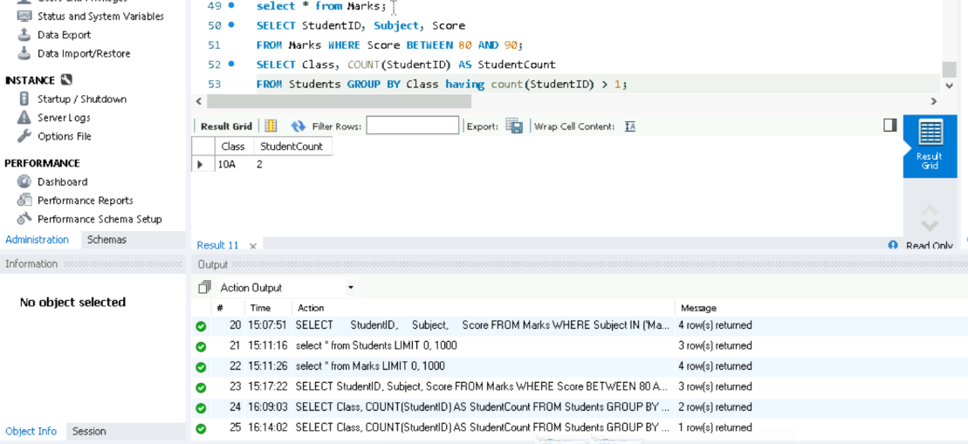

EXISTS – Checks if a subquery returns any rows.

